Exp 3: Bus Ticket Booking System
AIM
To design and develop an Online Bus Ticket Booking System using HTML, CSS, and JavaScript that enables users to search buses, register or log in, and book tickets with fare calculation.
Sample code
<!DOCTYPE html>
<html>
<head>
<title>Bus Ticket Booking System</title>
<style>
body {
font-family: Arial, sans-serif;
margin: 0;
background: #eef3f8;
color: #222;
}
header {
background: #12345a;
color: white;
text-align: center;
padding: 22px;
}
nav {
background: #e76f28;
padding: 13px;
text-align: center;
}
nav a {
color: white;
text-decoration: none;
margin: 15px;
}
.container {
background: white;
width: 85%;
max-width: 600px;
margin: 20px auto;
padding: 20px;
border-radius: 10px;
box-shadow: 0 2px 8px #ccc;
}
input, select {
width: 90%;
padding: 10px;
margin: 8px 0;
box-sizing: border-box;
}
button {
background: #e76f28;
color: white;
border: none;
padding: 11px 18px;
border-radius: 5px;
cursor: pointer;
}
button:hover {
background: #c65316;
}
.bus {
background: #f1f6fb;
margin: 10px 0;
padding: 12px;
border-left: 5px solid #12345a;
}
.result {
color: green;
font-weight: bold;
}
</style>
</head>
<body>
<header>
<h1>GoBus - Online Bus Booking</h1>
<p>Book your journey with comfort</p>
</header>
<nav>
<a href="#search">Search Bus</a>
<a href="#login">Login</a>
<a href="#booking">Book Ticket</a>
</nav>
<div class="container" id="search">
<h2>1. Search Bus</h2>

<input id="source" placeholder="From (e.g. Chennai)">
<input id="destination" placeholder="To (e.g. Bangalore)">
<input type="date" id="travelDate">
<button onclick="searchBus()">Search Buses</button>
<div id="searchResult"></div>
</div>
<div class="container" id="login">
<h2>2. User Registration / Login</h2>
<input id="username" placeholder="Enter your name">
<input type="email" id="email" placeholder="Enter your email">

<button onclick="login()">Register / Login</button>
<p class="result" id="loginResult"></p>
</div>
<div class="container" id="booking">
<h2>3. Book Bus Ticket</h2>
<label>Select Bus:</label><br>
<select id="busType">
<option value="Volvo AC">Volvo AC - ₹1200</option>
<option value="Sleeper Coach">Sleeper Coach - ₹900</option>
<option value="Ordinary Coach">Ordinary Coach - ₹500</option>
</select><br>
<label>Number of Seats:</label><br>
<input type="number" id="seats" min="1" max="6" value="1">
<button onclick="bookTicket()">Book Ticket</button>
<p class="result" id="bookingResult"></p>
</div>
<div class="container">
<h2>Available Bus Categories</h2>
<div class="bus">
<h3>Volvo AC</h3>
<p>Air-conditioned bus with comfortable seating.</p>
<b>₹1200 per seat</b>
</div>
<div class="bus">
<h3>Sleeper Coach</h3>
<p>Comfortable sleeper bus for long journeys.</p>
<b>₹900 per seat</b>
</div>
<div class="bus">
<h3>Ordinary Coach</h3>
<p>Affordable bus for everyday travel.</p>
<b>₹500 per seat</b>
</div>
</div>
<div class="container">
<h2>Contact Us</h2>
<p>Email: support@gobus.example</p>
<p>Phone: 9876543210</p>
</div>
<script>
let loggedIn = false;

const busPrices = {
"Volvo AC": 1200,
"Sleeper Coach": 900,
"Ordinary Coach": 500
};

function searchBus() {
let from = document.getElementById("source").value.trim();
let to = document.getElementById("destination").value.trim();
let date = document.getElementById("travelDate").value;

let result = document.getElementById("searchResult");

if (!from || !to || !date) {
result.innerHTML =
"<p style='color:red'>Enter source, destination and date.</p>";
return;
}

if (from.toLowerCase() === to.toLowerCase()) {
result.innerHTML =
"<p style='color:red'>Source and destination must differ.</p>";
return;
}
if (date < new Date().toLocaleDateString("en-CA")) {
result.innerHTML =
"<p style='color:red'>Choose today or a future date.</p>";
return;
}
result.innerHTML =
"<p class='result'>Buses found for " +
from + " to " + to + " on " + date + ".</p>" +
"<p>Volvo AC - ₹1200 | Sleeper Coach - ₹900 | " +
"Ordinary Coach - ₹500</p>";
}

function login() {
let name = document.getElementById("username").value.trim();
let email = document.getElementById("email").value.trim();

if (!name || !email || !email.includes("@")) {
document.getElementById("loginResult").innerText =
"Enter a name and valid email.";
return;
}
loggedIn = true;
document.getElementById("loginResult").innerText =
"Welcome, " + name + "! You can book your ticket.";
}

function bookTicket() {
let type = document.getElementById("busType").value;
let seats = Number(document.getElementById("seats").value);
let result = document.getElementById("bookingResult");

if (!loggedIn) {
result.innerText = "Please register or log in first.";
return;
}
if (!Number.isInteger(seats) || seats < 1 || seats > 6) {
result.innerText = "Select between 1 and 6 seats.";
return;
}
let total = busPrices[type] * seats;
result.innerHTML =
"Ticket Booked Successfully!<br>" +
"Bus: " + type + "<br>" +
"Seats: " + seats + "<br>" +
"Total Fare: ₹" + total;
}
</script>
</body>

</html>
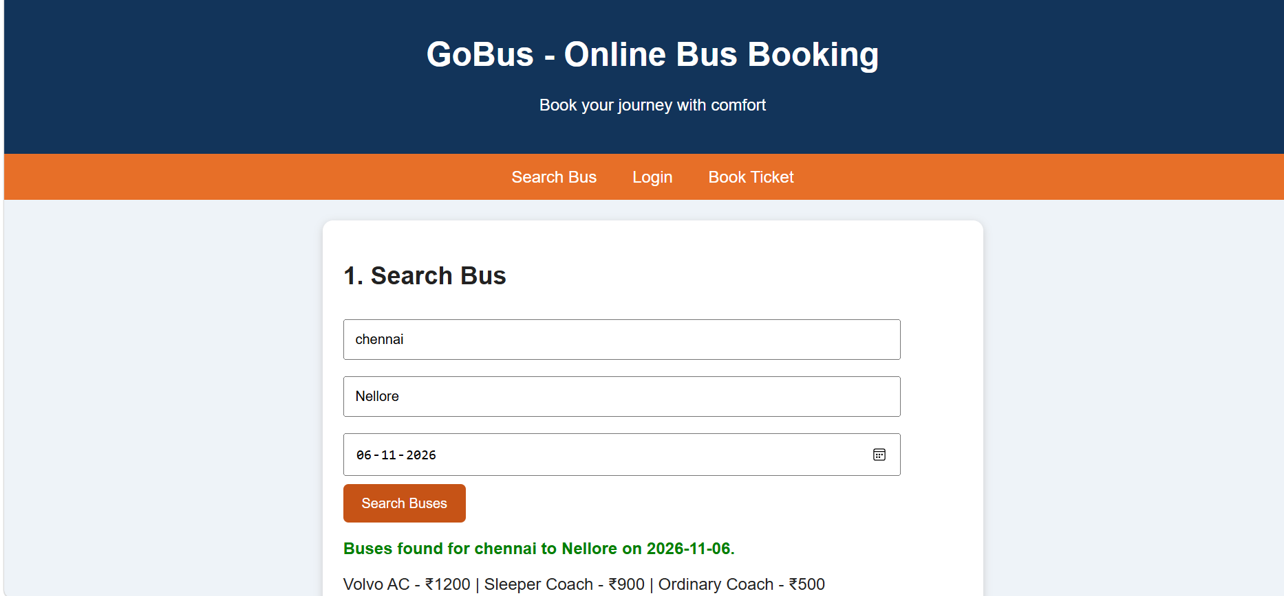
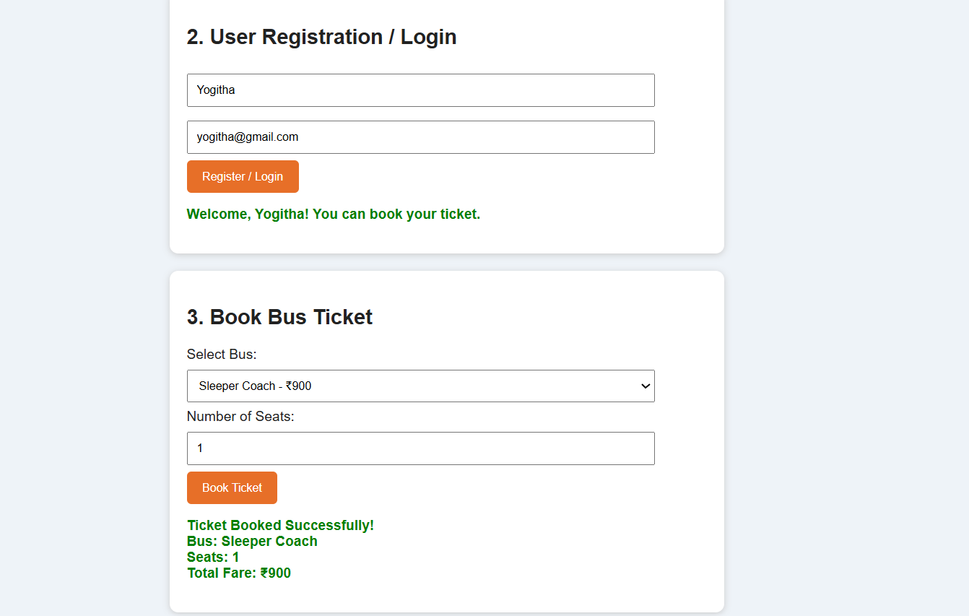

RESULT
Thus, the Online Bus Ticket Booking website was developed successfully with three working functionalities: bus search, user registration/login demonstration, and ticket booking with fare calculation.

